 |  |  |  | Memory  First Year  in Engineer Cycle  on  Computer science
République Tunisienne
Ministère de l’Enseignement Supérieur
et de la Recherche Scientifique
Université de Sfax
The Higher Institute of International Institute of Technology of Sfax

PROJECT REPORT
presented to

The Higher Institute of International Institute of Technology of Sfax (IIT)
in order to obtain the diploma of

Engineer

Specialization: Big Data and Data Analysis

Portofolio site

:



Prepared by :

Rabie Baccouch

Defended on 08/12/2024:
Mr. | Abdel Moula | Chef Department

College year: 2024-2025

Introduction :
A portfolio website serves as a personal showcase of an individual's skills, projects, and achievements, making it a critical tool for personal branding, especially in the fields of design, development, and creative industries. This report presents the development process of a portfolio website using core web technologies: HTML, CSS, and JavaScript. The purpose of this report is to demonstrate how these technologies were employed to create a visually appealing, functional, and user-friendly portfolio.

Chapter 1: Designing the Structure with HTML
HTML (Hypertext Markup Language) is the foundation of any website, providing the structure and content. In this chapter, we will explore how HTML was used to create a structured layout for the portfolio. The site includes essential sections such as:
- Header: Contains the navigation bar, logo, and links to other sections of the site.
- About Me: A brief introduction with personal background information.
- Projects: A display of selected work, with project descriptions and links to view more details.
- Contact: A contact form to allow visitors to reach out easily.
- Footer: Includes copyright information and links to social media profiles.



Chapter 2: Styling the Site with CSS
CSS (Cascading Style Sheets) was utilized to enhance the visual appeal of the portfolio site. In this chapter, we discuss how CSS was used to:
• Layout Design: Implement responsive design principles to ensure the site works well on all devices (desktop, tablet, mobile).
• Typography: Chosen fonts that align with the site's aesthetic, improving readability and user experience.
• Colors and Themes: A harmonious color palette was selected to create a clean, professional look while enhancing the visual flow.
• Animations: Subtle animations were added to enhance the user experience, such as hover effects on buttons and smooth transitions between sections.

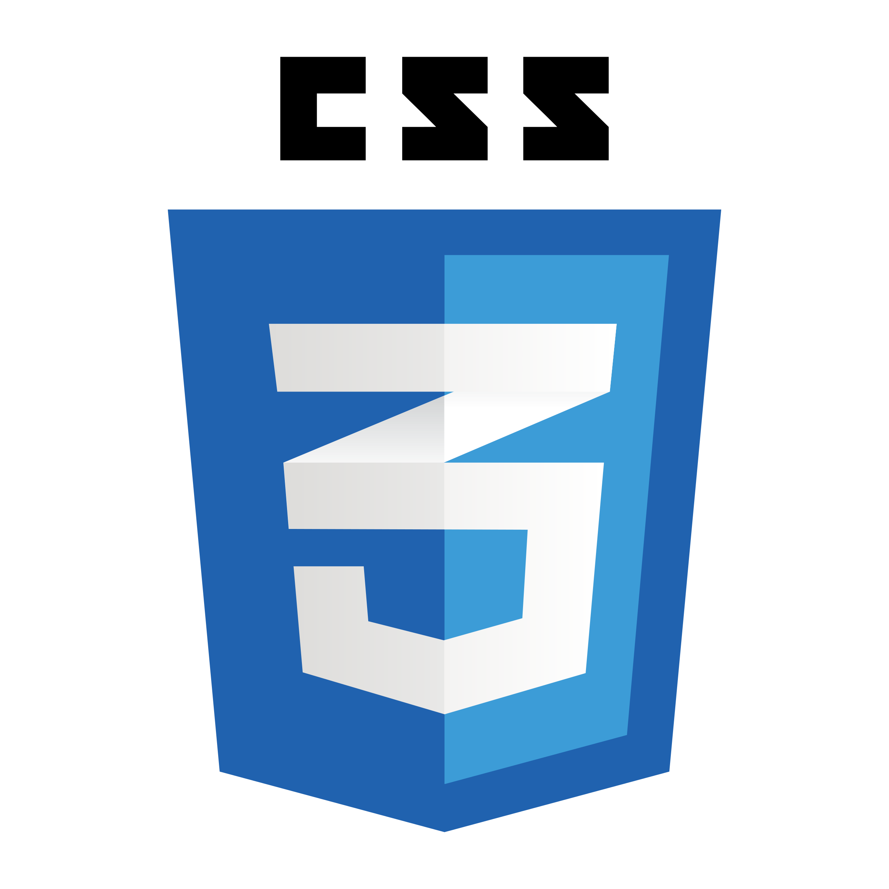

Chapter 3: Enhancing Interactivity with JavaScript
JavaScript was used to add interactive elements to the portfolio site, making it more engaging. This chapter covers how JavaScript was employed to:

• Form Validation: Ensures that the contact form is filled out correctly before submission.
• Dynamic Content Loading: Implements techniques like lazy loading to improve the site's performance by loading content dynamically.
• Interactive Features: Adds features like a lightbox for viewing project images and a smooth scroll effect for navigation.



Chapter 4: Screenshots of portfolio site

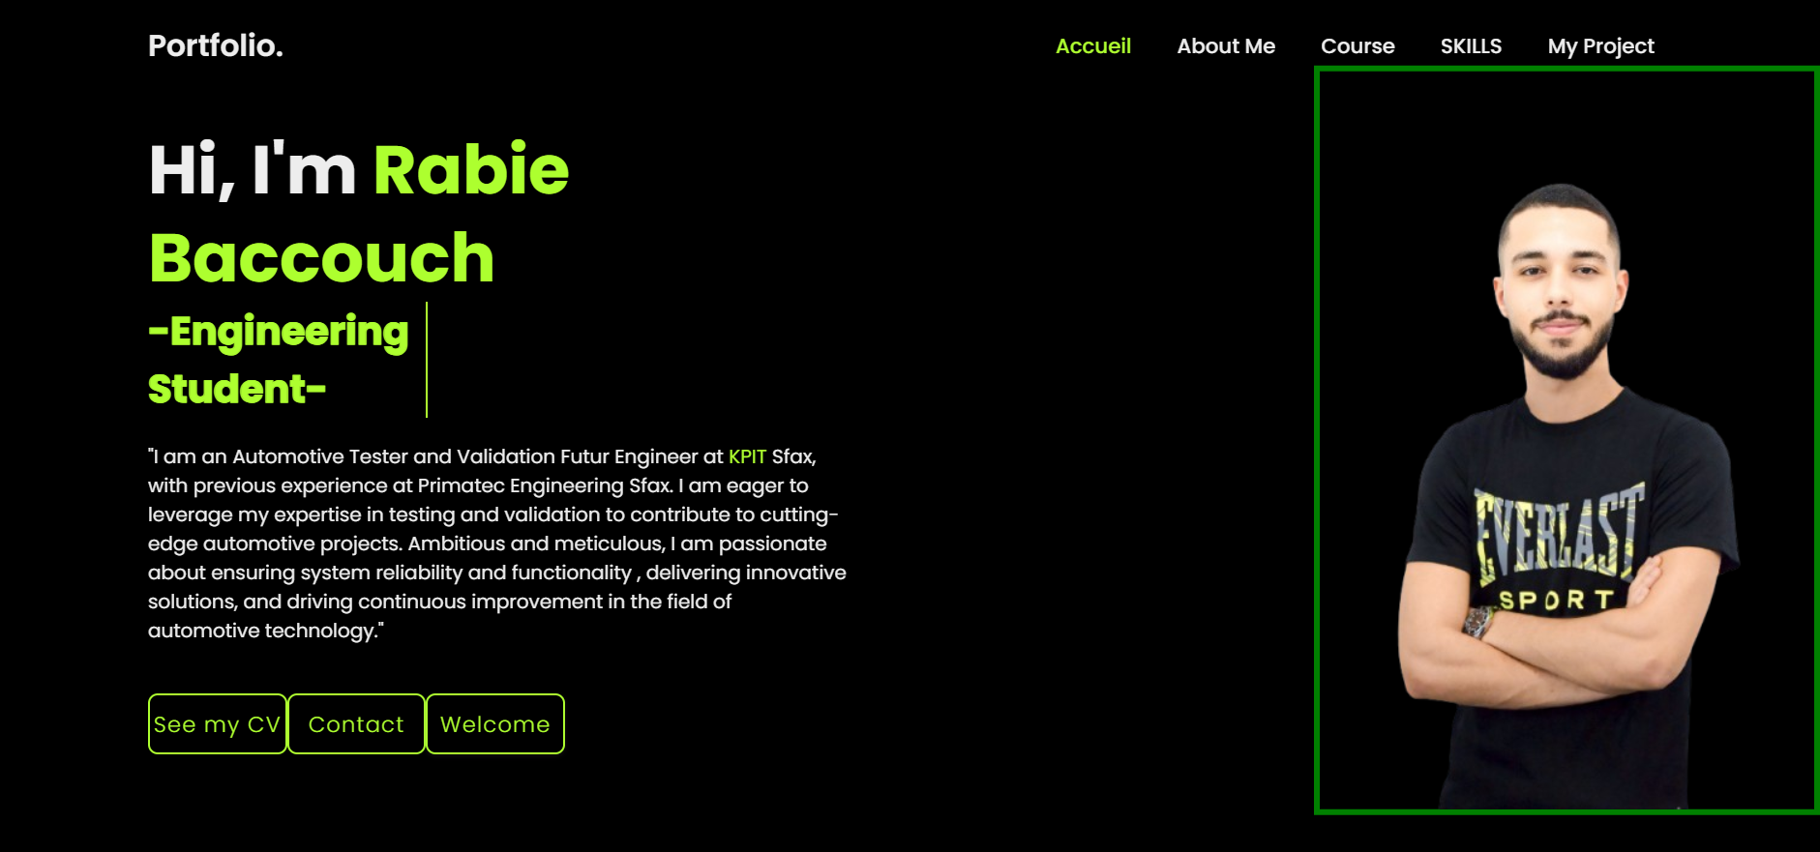
Header Section:
- Logo: A logo is displayed with the text "Portfolio" and an animated effect applied to it.
- Navigation Bar: Contains links to different sections of the page:
  - "Accueil" (Home)
  - "About Me"
  - "Course" (Education)
  - "Skills"
  - "My Project" (Projects)
  - The navigation bar has an active link indicator and some animation effects.

Home Section:
- Main Heading: "Hi, I'm Rabie Baccouch" – this introduces the person behind the portfolio.
- Subheading: "Engineering Student" – highlights the user's current role.
- Personal Description: A paragraph detailing the user's professional background:
  - Rabie Baccouch works as an Automotive Tester and Validation Engineer at KPIT in Sfax, with previous experience at Primatec Engineering in Sfax.
  - Mentions eagerness to contribute to automotive projects, focus on system reliability, and drive innovation in automotive technology.
  - There is a hyperlink to the KPIT website with the text "KPIT" styled in green-yellow.
- Buttons:
  - See my CV: A link to Rabie's CV in PDF format.
  - Contact: A link to a contact form (formulaire.html).
  - Welcome Button: A button styled with the text "Welcome" for interactive engagement.

See my cv :
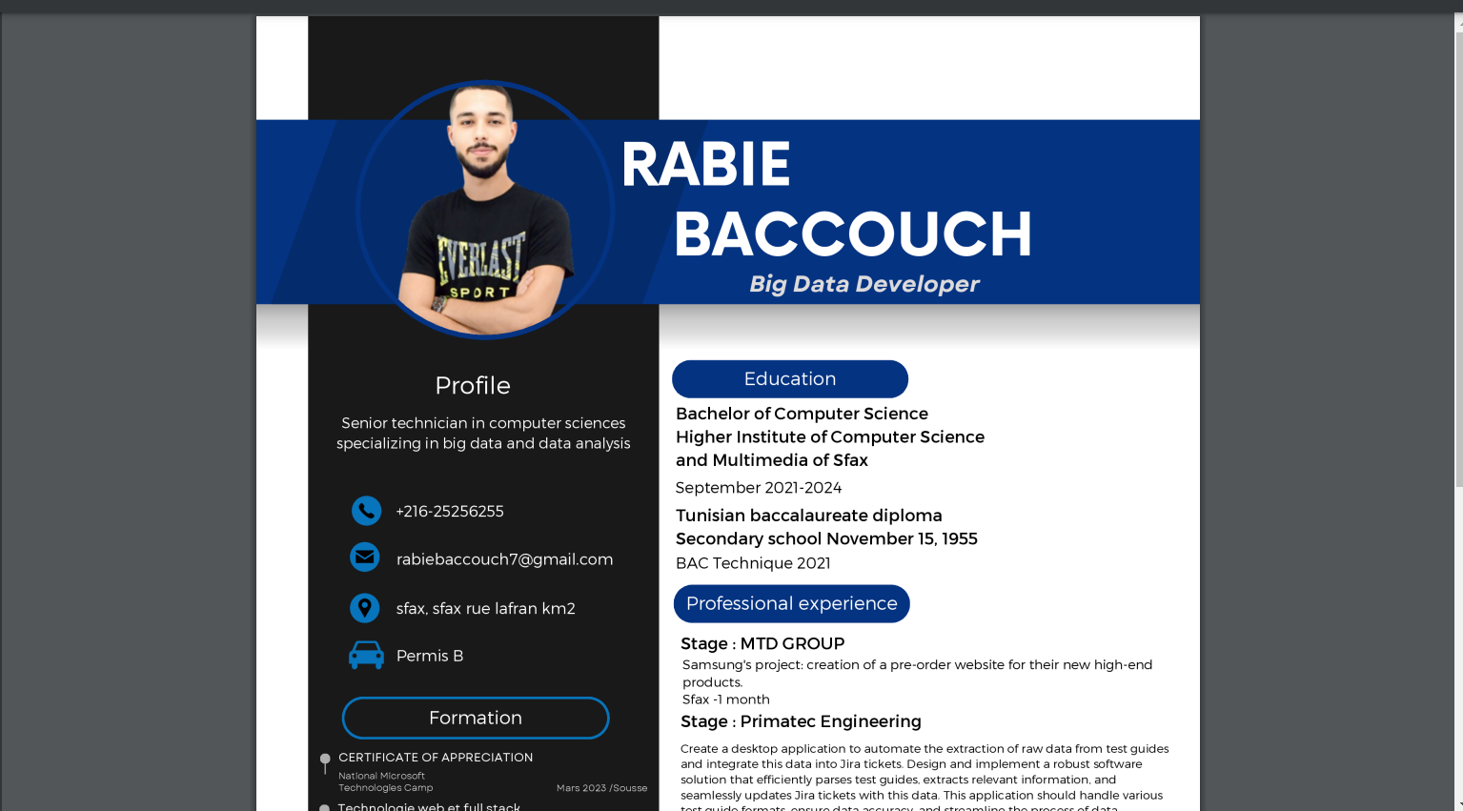
Contact page: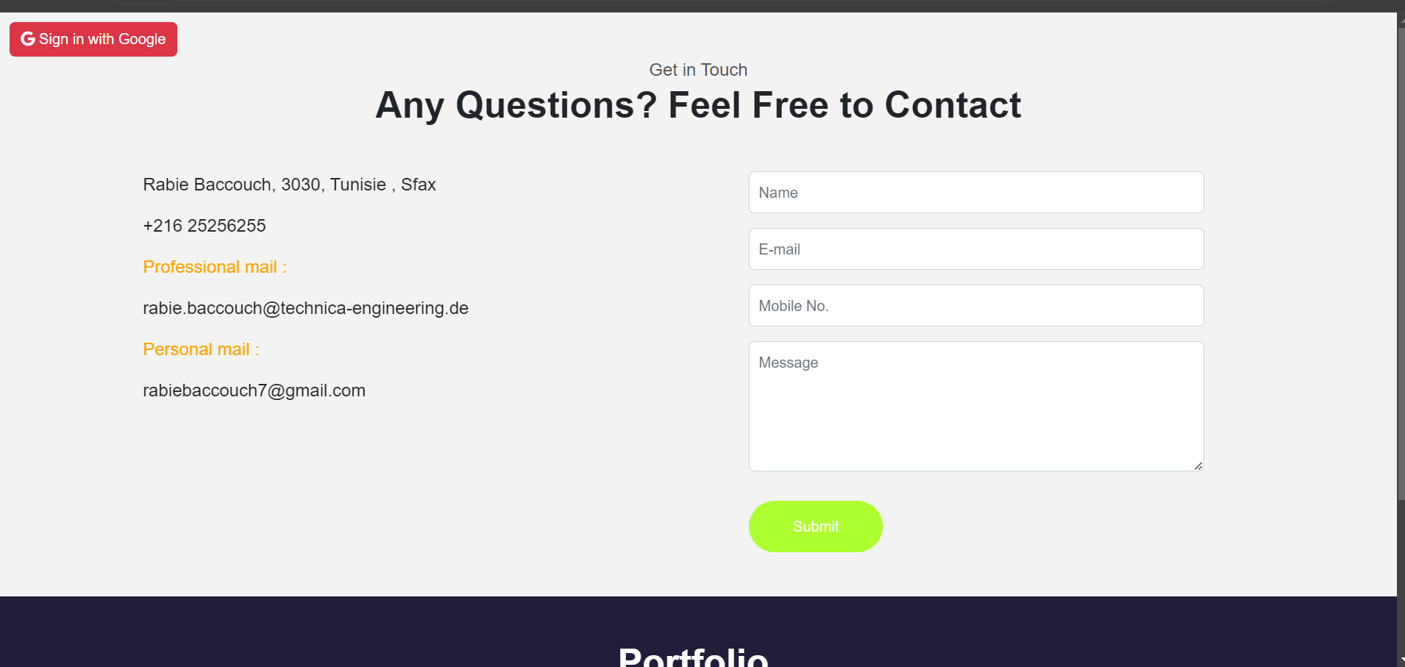
Google Sign-In Button:
- Button for Google Sign-In: A button with a Google sign-in option, styled with the class btn btn-danger, which includes a Google icon. This feature allows users to sign in using their Google account.

Contact Section:
- Heading: A section heading titled "Any Questions? Feel Free to Contact" is centered with a smaller subtitle "Get in Touch."
- Contact Details:
  - Location: "Rabie Baccouch, 3030, Tunisie, Sfax," displayed with a map location icon (bi bi-geo-alt-fill).
  - Phone Number: The contact phone number is listed with a telephone icon (bi bi-telephone-fill).
  - Email Addresses: Professional and personal email addresses are provided with a mail icon (bi bi-send-fill), with different colors used to highlight the professional and personal emails.
  - Website (Globe Icon): A globe icon (bi bi-globe-americas) is included, although there is no website link specified in this part of the code.
- Contact Form:
  - Input Fields:
    - Name: A text input field for the user's name.
    - Email: A text input field for the user's email.
    - Mobile No.: A text input field for the user's mobile number.
    - Message: A textarea input field for the user to leave a message.
  - Submit Button: A button for submitting the form, with the class c-btn h-btn and rounded-pill styling for a more modern design.

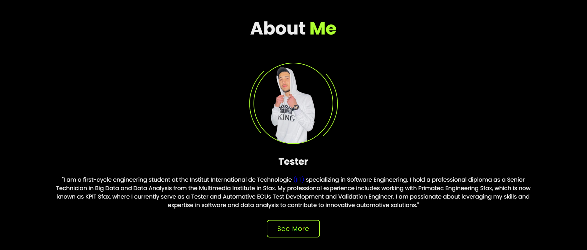
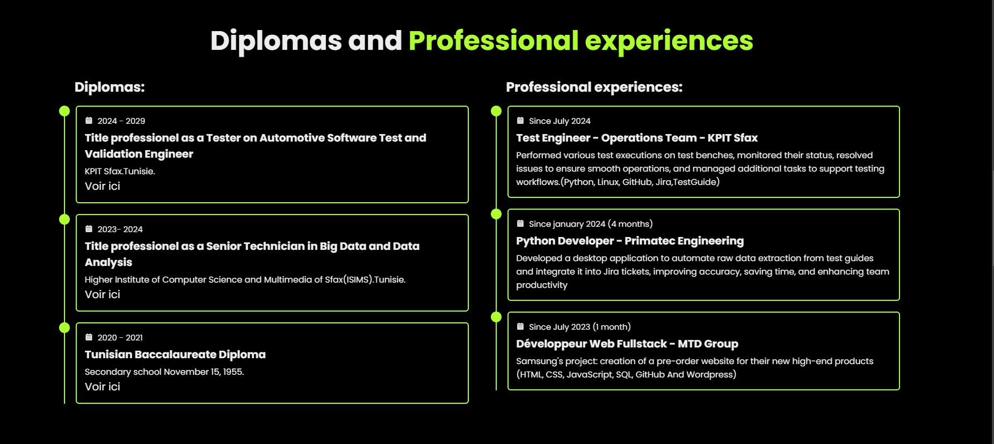
1. About Section:
- Heading: "About Me" with the main heading "About" and a subheading "Me." The content includes animations triggered during scrolling.
- Profile Image: An image (cardprofile1.png) of the individual is displayed, surrounded by an animated circular effect (circle-spin).
- About Content:
  - Title: "Tester" is displayed as the job title.
  - Description: A paragraph describing the individual's background, education, and career:
    - Currently a first-cycle engineering student at the Institut International de Technologie (IIT) in Software Engineering.
    - Holds a professional diploma as a Senior Technician in Big Data and Data Analysis from the Multimedia Institute in Sfax.
    - Professional experience at Primatec Engineering Sfax (now KPIT Sfax) as a Tester and Automotive ECUs Test Development and Validation Engineer.
    - Passionate about using skills in software and data analysis to contribute to innovative solutions in the automotive industry.
    - The IIT link is styled with a blue color to stand out.
- "See More" Button: A button linking to an about.html page for further details.

2. Education Section:
- Heading: "Diplomas and Professional Experiences" with animations triggered on scroll.
- Education Section:
  - Diplomas:
    - 2024 - 2029: Professional title as Tester on Automotive Software Test and Validation Engineer at KPIT Sfax, Tunisia. A PDF link to the contract document (contrat.pdf).
    - 2023 - 2024: Professional title as Senior Technician in Big Data and Data Analysis at the Higher Institute of Computer Science and Multimedia of Sfax (ISIMS). A PDF link to the diploma (license.pdf).
    - 2020 - 2021: Tunisian Baccalaureate Diploma from Secondary School November 15, 1955. A PDF link to the Baccalaureate document (bac.pdf).
- Professional Experiences:
  - Since July 2024: Test Engineer at KPIT Sfax, responsible for executing tests, monitoring test benches, resolving issues, and supporting testing workflows. Technologies used include Python, Linux, GitHub, Jira, TestGuide.
  - Since January 2024: Python Developer at Primatec Engineering (now KPIT), where the individual developed a desktop application to automate data extraction from test guides into Jira tickets.
  - Since July 2023: Fullstack Web Developer at MTD Group, working on a project for Samsung to create a pre-order website for their high-end products using HTML, CSS, JavaScript, SQL, GitHub, and WordPress.
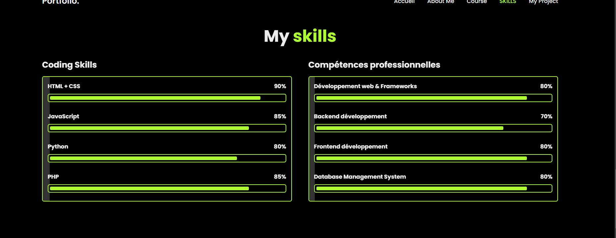
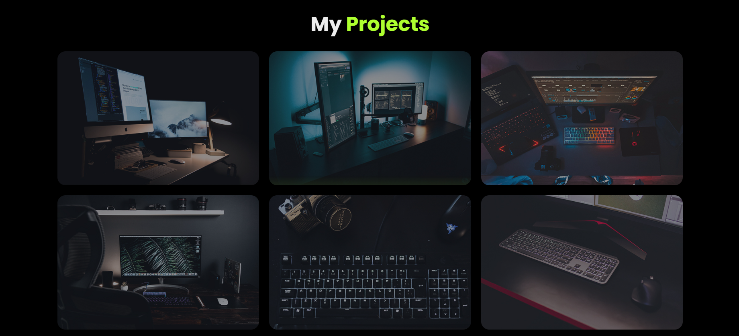
This HTML code describes two sections of a personal portfolio: Skills and Projects. Below is a detailed breakdown of the content in these sections:

1. Skills Section:
- Heading: "My Skills" with animations applied on scrolling.
- Skills Overview:
  - The section is divided into two columns: Coding Skills and Professional Skills.
  - Coding Skills:
    - A list of skills with proficiency percentages displayed using progress bars.
    - Skills included:
      - HTML + CSS: 90%
      - JavaScript: 85%
      - Python: 80%
      - PHP: 85%
    - Each skill is presented with a progress bar that visually shows the percentage of proficiency.
  - Professional Skills:
    - Another set of skills with proficiency percentages.
    - Skills included:
      - Web Development & Frameworks: 80%
      - Backend Development: 70%
      - Frontend Development: 80%
      - Database Management System: 80%
    - Like the coding skills section, these are also shown with progress bars to indicate proficiency.

2. Projects Section:
- Heading: "My Projects" with animations triggered on scroll.
- Portfolio Overview:
  - This section showcases a series of projects in a portfolio container with individual project boxes. Each box includes:
    - Project Image: An image related to the project.
    - Project Title: A title describing the project.
    - Project Description: A brief description of the project and the technologies used.
    - External Link: A clickable link that opens the project in a new tab, indicated by an external link icon (bx bx-link-external).
    - Focus Effect: A visual "focus" effect applied to the project boxes.
  - Projects showcased:
    - SAMSUNG Galaxy Z-fold5: Built with HTML + CSS and WordPress using Elementor for the client albadeel-MTD Group. Link to the product page.
    - SAMSUNG Galaxy Z-flip 5: Similar to the first project, built with HTML + CSS and WordPress using Elementor for the same client.
    - Solar System Animation: A project built with HTML + CSS, showcasing an animated solar system.
    - Website for Breast Segmentation and Classification: A project built with HTML + CSS + PHP Laravel, incorporating AI for medical image segmentation.
    - GitHub Projects: A link to the individual's GitHub profile showcasing various projects developed with Angular, HTML, CSS, JS, and TS.
    - Personal Card Project: A project showcasing personal creations and a link to the individual’s contact details.

